**Course 5**

**Topic:**

**SOFT TISSUE AUGMENTATION TECHNIQUES AROUND TEETH AND IMPLANTS (HANDS-ON WORKSHOP ON SHEEP JAWS)**

**Faculty:**

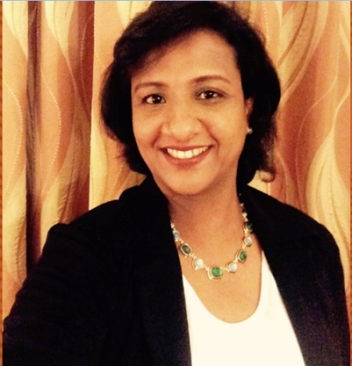

Dr. Joan Pauline George

**Objectives**

Basics in soft tissue grafting-

1. Learn various flaps and suturing techniques.
2. Perform coronally advanced flap with / without connective tissue grafting.
3. Perform free gingival grafting

**Capacity:** 40

**Fee:** 2000/-