**Course 8**

**Topic:**

**PROBLEM SOLVING IN ENDODONTICS**

**Faculty:**

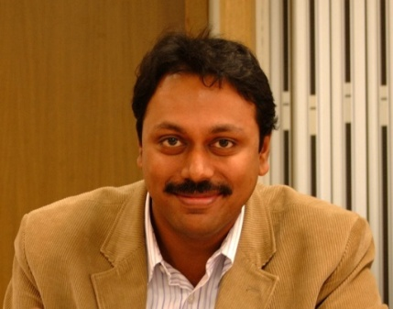

Dr. Gopikrishna

**Objectives**

Endodontics is considered to be the foundation of a successful clinical practice. Practicing quality oriented endodontics involves a combination of knowledge and clinical acumen. This presentation followed by hands on will give an evidence based update on the common errors and challenges that practitioners face and provide clinical solutions for the same.

The hands on will focus on ergonomic use of rotary endodontics for predictable shaping of the root canal. The program will give an overview on the various materials and techniques available today to enhance the quality of contemporary endodontic practice.

• Evidence based update on the common errors and challenges in clinical situation

• Management of these challenges

• Hands on will focus on ergonomic use of rotary endodontics for predictable shaping of the root canal.

• The program will give an overview on the various materials and techniques available today to enhance the quality of contemporary endodontic practice.

• Handson participants get kit worth Rs 6000/-

**Lecture Fee :** 1000/-

**Lecture + Workshop Fee :** 3500/- **Capacity:** 15