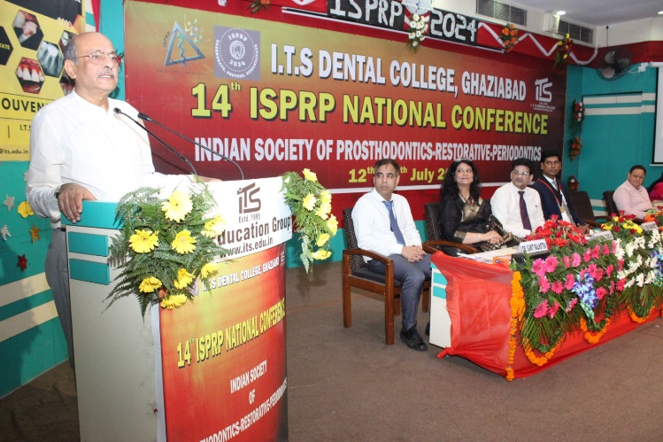

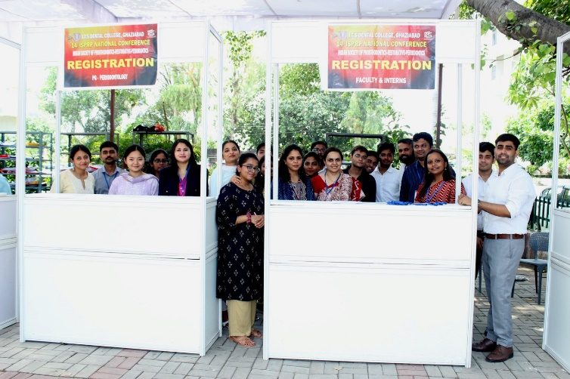

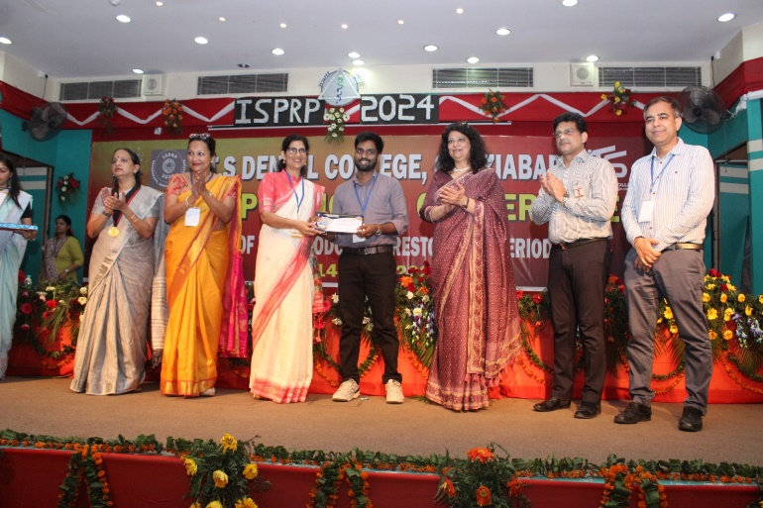

**Event Report: 14th National ISPRP Conference (12-14 July 2024)**

I.T.S Dental College, Ghaziabad hosted the 14th ISPRP Annual National Conference 2024 in collaboration with the Indian Society of Prosthodontics-Restorative-Periodontics (ISPRP). The event saw participation from 546 delegates, including interns, postgraduates, and faculty from across India. The conference featured 3 pre-conference courses, 9 keynote lectures, and a symposium by renowned speakers.

A total of 319 scientific presentations, including 244 papers and 75 posters, were showcased. The trade fair, with 15 prominent dental companies, facilitated networking and highlighted innovations. Keynote sessions covered topics like endo-perio continuum, full-mouth rehabilitation, and digital implant prosthodontics. The event also included guest lectures, paper presentations, and a symposium on advanced dental technologies. The conference concluded with a valedictory function, prize distribution, and optimistic discussions on future collaborations.