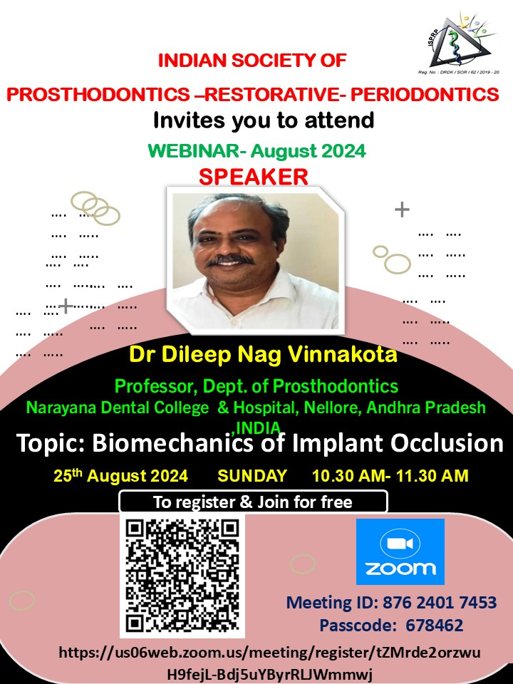

🦷 **Join Us for an Exciting Webinar!** 🦷

Greetings from the Indian Society of Prosthodontics-Restorative-Periodontics!

📅 **Date:** 25th August 2024  
⏰ **Time:** 10:30 AM - 11:30 AM  
🎓 **Speaker:** Prof. Dr. Dileep Nag Vinnakota  
💡 **Topic:** Biomechanics of Implant Occlusion

Don't miss out on this insightful session! Register now using the link below and enhance your knowledge in implant dentistry.

🔗 [Register Here](https://us06web.zoom.us/meeting/register/tZMrde2orzwuH9fejL-Bdj5uYByrRLJWmmwj) : <https://us06web.zoom.us/meeting/register/tZMrde2orzwuH9fejL-Bdj5uYByrRLJWmmwj>

Once registered, you’ll receive the event link via email. If you don’t see it, be sure to check your clutter/spam/junk folder.

Spread the word and invite your students & colleagues! 📢

#Prosthodontics #RestorativeDentistry #Periodontics #ImplantOcclusion #Webinar #DentalEducation #ISPRP #DentalWebinar #DentalImplants

**Dear Fellow Dentists**,

“Greetings From Indian Society of Prosthodontics-Restorative-Periodontics”

Kindly register for the upcoming webinar titled **“Biomechanics of Implant occlusion” on 25th August 2024** from 10.30 to 11.30am by **Prof**. **Dr. Dileep Nag Vinnakota**.

Kindly do register using the link [**https://us06web.zoom.us/meeting/register/tZMrde2orzwuH9fejL-Bdj5uYByrRLJWmmwj**](https://us06web.zoom.us/meeting/register/tZMrde2orzwuH9fejL-Bdj5uYByrRLJWmmwj)

Once registered, the event link will be sent to your email. If not received, kindly check your clutter/spam/ junk mail section. Please use the link to join the event at 10.30 am on 4th Sunday of this month. Please forward this email to your students &/or colleagues.

This webinar will be **free** for ISPRP members as well as non-members. The numbers are limited to 100 (it will be on a first-come, first-served basis). Members can access the webinar through **YouTube Live** if Zoom is full.

If NOT a member, be an ISPRPian.

Life Membership fee is just Rs.5310/- for more details check - <http://isprp.org/Assc_WebPages/MemberRegistration.aspx>

**For more information & queries- Dr. Anitha. K.V, Membership committee chairman**

**Email Id: Isprpsecretary@gmail.com**

Regards

**ISPRP 2024-25 team**