**Course 1**

**Topic:**

**CLINICAL RESEARCH- METHODOLOGY AND BIOSTATISTICS**

**Faculty:**

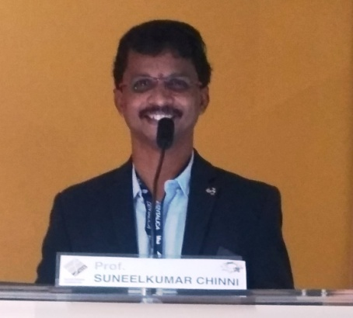 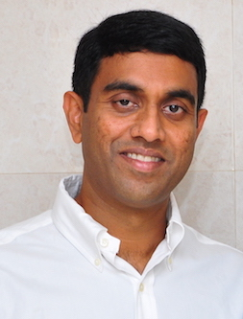

Dr. Suneel Kumar Chinni Dr. Sreenivas Nagarakanti

**Objectives**

Learning objectives : (1) To sensitize the participants towards clinical research. (2) to enable course participants to frame the research question for different study designs and able to search the literature in different data bases (3) to understands which check list need to follow for different study designs.(4) to be able to frame research question for systematic reviews and registration of systematic reviews in PROSPERO. (5) Importance of COCHRANE data base for Meta analysis

**Capacity:** 40

**Fee:** 900/-