**Course 2**

**Topic:**

***DO IT YOURSELF- DENTAL PHOTOGRAPHY***

1. **DSLR CAMERA WILL BE PROVIDED TO PARTICIPANTS DURING HANDS-ON WORKSHOP**
2. **PERSONAL DSLR CAMERA CAN ALSO BE BOUGHT**

**Faculty:**

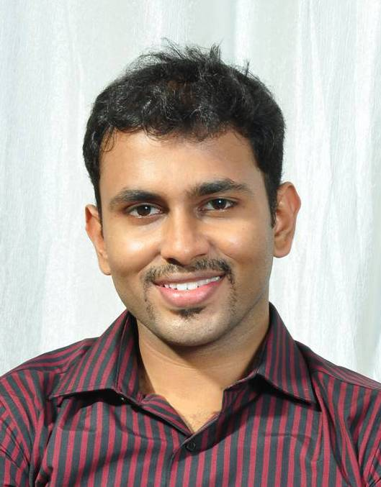

Dr. Praveen Rajesh

**Objectives**

Learning Objectives : (1) To appreciate the uses of Dental photography in practice (2) To differentiate the advantages and limitations of mobile phone and DSLR photography (3) To briefly understand the basic principles of dental photography (4) To understand the settings required for intraoral and extra oral photography (5) To have a brief hands on of Intraoral Photography (1 or 2 views )

(All participants will receive a DSLR and a typhodont for the hands on.)

**Capacity:** 20

**Fee:** 1800/-