**Course 4**

**Topic:**

**CLINICAL LASER DENTISTRY (HANDS-ON WORKSHOP ON SHEEP JAWS)**

**Faculty:**

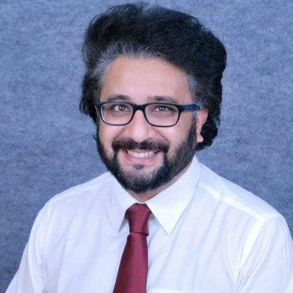

Dr. Kirpa Johar

**Objectives**

Learning Objectives : (1) to give the participants an insight on the advantages of non-invasive Laser Dentistry.(2) How intergration of laser dentistry into the Dental practice enhances treatment protocols and also helps in growth of the Dental practice due to enhanced treatment modalities which ultimately leads to greater patient satisfaction and greater patient referrals.

**Capacity:** 40

**Fee:** 2000/-