**Course 6**

**Topic:**

**DENTAL IMPLANTS FOR BEGINNERS/DENTAL PRACTITIONERS**

**Faculty:**

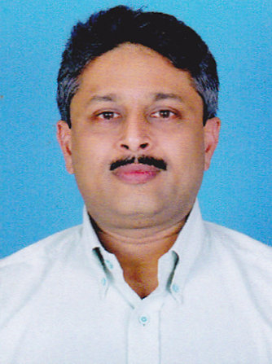

Dr. Sreekanth. A. Mallan

**Objectives**

-

**Capacity:** 40

**Fee:** 2500/-