**Course 7**

**Topic:**

**PRF WORKSHOP- LECTURE AND DEMONSTRATION**

**Faculty:**

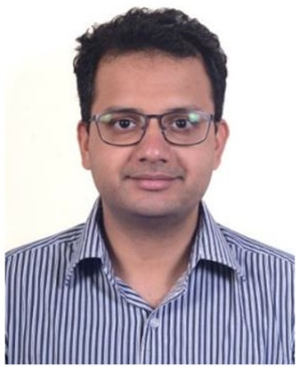

Dr. Mihir Kulkarni

**Objectives**

**Part 1 : Lecture / Discussion**

* Biology of Platelet-rich fibrin (PRF)
* Controversies in nomenclature and protocols for preparation of PRF

1. Various types of PRF and proposed protocols
2. Controversies in nomenclature
3. Classification of PRF
4. Tips and tricks for easy and predictable PRF preparation

* Clinical applications of PRF – evidence based approach
* Future trends in PRF research

**Part 2: Demonstration (on volunteer)**

* Phlebotomy technique
* Preparation of PRF
* Preparation of injectable PRF (iPRF)
* Preparation of “sticky bone” using iPRF

**Capacity:** 30

**Fee:** 600/-