**Course 9**

**Topic:**

**“PIEZOSURGERY – A GAME CHANGER FOR INTERDISCIPLINARY PROCEDURES IN DENTISTRY”**

**Faculty:**

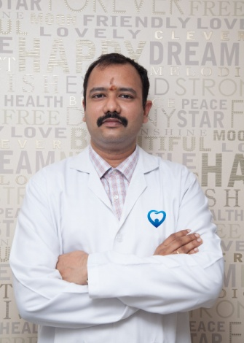

Dr. Vamsi Lavu **MDS, PhD, MSc in Lasers (Germany)**

**Objectives**

**Course Content:**

* Piezosurgery- Rationale for use. When, Where and Why?
* Biological effects of Piezosurgery.
* Mechanisms of working and Advantages and Limitations.
* Device and tips used for different procedures.
* Clinical applications
* Why – a Game changer in Interdisciplinary procedures and clinical practice

**Hand on Session- Goat mandible: in the Afternoon- for limited participants- Block grafting and tooth extraction.**

Supported by Acteon India Limited.

* Lecture with Hands-on Goat mandible Rs 1750 (inclusive of GST) (Max 10 participants).

**Capacity:** 10

**Fee:** 600/-