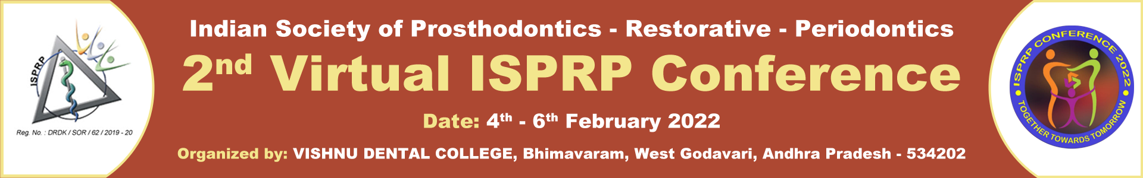

|  |  |  |  |  |
| --- | --- | --- | --- | --- |
| FACULTY PRESENTATION | | | | |
| Session | Reg. No. | Place | Name | College |
| 15 | 107 | 1st | Dr. POORNIMA RAJENDRAN  Dr. RAJESH R | SRI RAMAKRISHNA DENTAL COLLEGE AND HOSPITAL, TAMILNADU |
| 15 | 3 | 2nd | Dr. PRATIBHA SHASHIKUMAR | JSS DENTAL COLLEGE AND HOSPITAL, KARNATAKA |
| 15 | 265 | Consolation | Dr. PRAVEEN KUMAR BANKUR | AL BADAR DENTAL COLLEGE AND HOSPITAL |
| 20 | 152 | 1st | Dr. SRILEKHA J | SRI VENKATESHWARAA DENTAL COLLEGE |
| 20 | 320 | 2nd | Dr. SMITA DURGA DUTTA | QASSIM DENTAL COLLEGE |
| 20 | 805 | Consolation | Dr. ANITHA SUBBAPPA | JSSDCH, JSSAHER |
| 25 | 239 | 1st | Dr. BODDEDA ANUSHA | VISHNU DENTAL COLLEGE, WEST GODAVARI DISTRICT |
| 25 | 146 | 2nd | Dr. ROOPALI DOSHETTY | AL BADAR DENTAL COLLEGE AND HOSPITAL |
|  |  |  |  |  |
| FACULTY POSTER | | | | |
| Sl No. | Reg. No. | Place | Name | College |
| 25 | 576 | 1nd | Dr. PRIYA LOCHANA GAJENDRAN | SAVEETHA DENTAL COLLEGE AND HOSPITAL, TAMILNADU |